# Exercise 4 - More about using SAS from JMP

JMP can integrate with SAS quite easily, allowing:

* SAS code to be run, with results returned to JMP
* Stored Processes to be run

1. SAS programming
   1. File/SAS/New SAS program

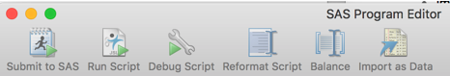

* + 1. Programs that produce data

data silly ;

set sashelp.class sashelp.shoes ;

run ;

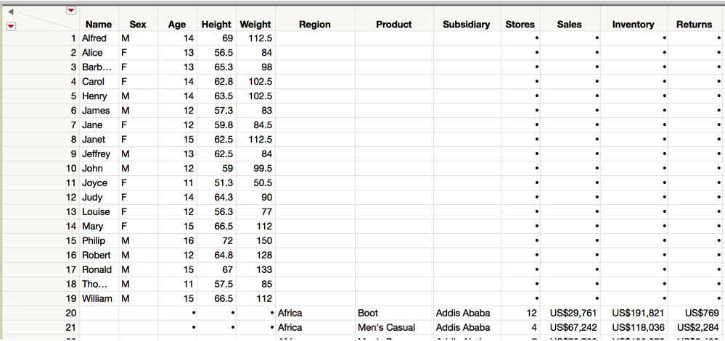

proc summary data=sashelp.class ;

class sex ;

var age ;

output out=class_summary mean= ;

run ;

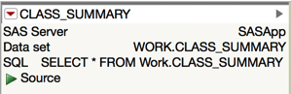

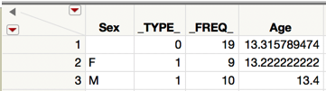

* + 1. Programs that produce ODS output

proc freq data=sashelp.shoes ;

run ;

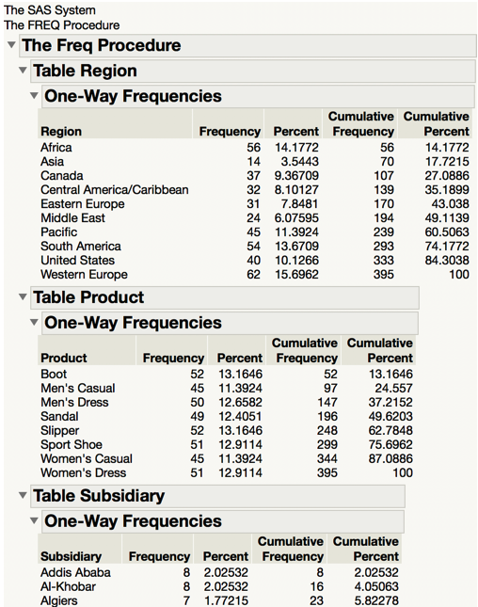

* + 1. Programs producing tables and ODS output

proc univariate data=sashelp.class  
 outtable=univariate_stats ;

run ;

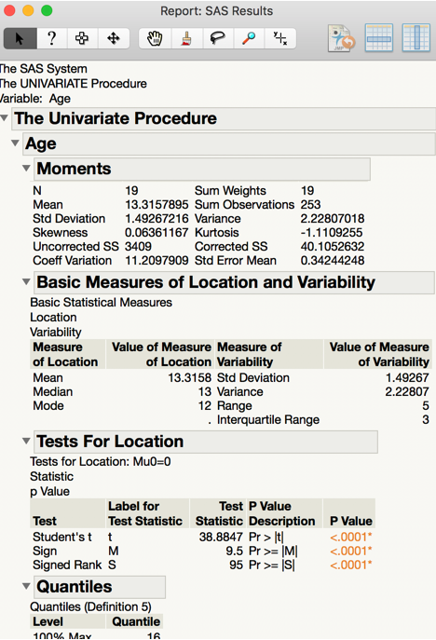

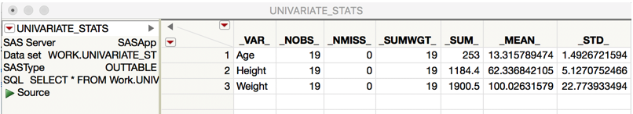

* 1. Submit to SAS
  2. Open SAS LOG

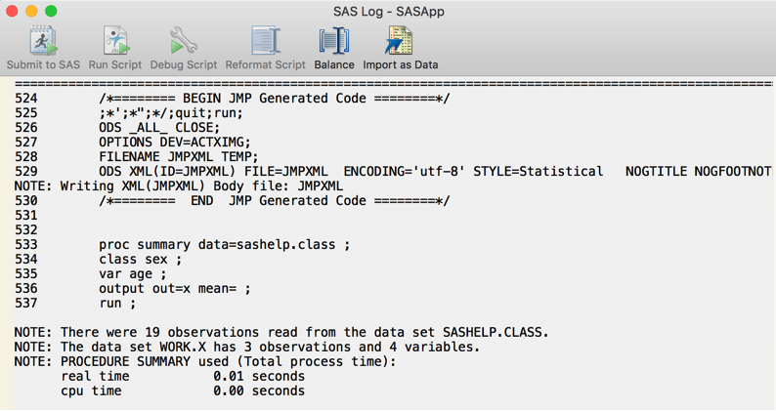

* 1. Open SAS Output

1. File/SAS/Browse SAS folders
   1. Import a table defined
   2. Run a stored process or stored process report